**Chapter 3 suggested homework problems - SOLUTIONS**

3.4 This problem is a straight-forward application of principles for an ideal transformer.

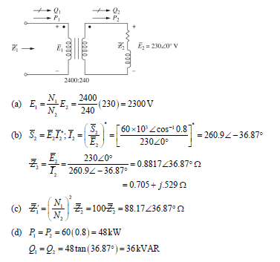

3.10 The short-circuit test described in section 3.2 can be used for “system identification”, that is, to find certain characteristics of a transformer primary winding.

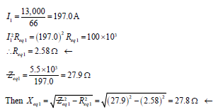

3.11 Here the open-circuit test is used on the same transformer to find other characteristics.



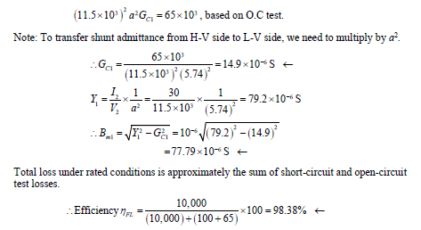

3.14 This is just a “bread and butter” analysis problem for a 10:1 step-down transformer.

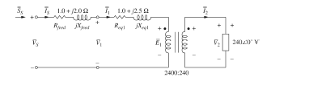

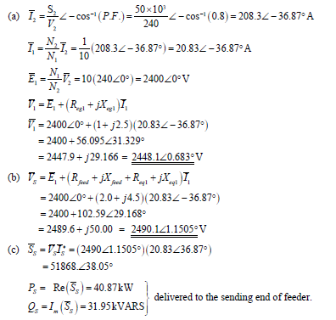

3.25 In the first computer lab, I give you the per-unit impedances to use for various components of the system. Here in this problem, you get to calculate these per-unit values.

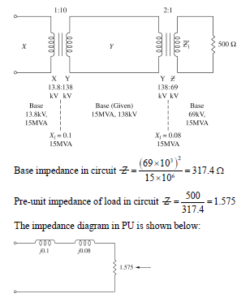

3.27. Here is more practice in determining per-unit impedance values.

3.35 This is a good problem to help with your understanding of different possible connections in a three-phase system.

3.43 This is another good problem for examining Y-Y and Y-Δ, primary-secondary, connections in a three phase transformer system.

